Predict 1: I predicted that the products would no longer be able to display their supplier information after del supplier, because I thought deleting the variable would remove the supplier. In fact, both the guitar and the photo editor still displayed the supplier’s details. My assumption was wrong because del supplier only removes the variable name, not the Supplier object itself. Each product stored its own reference to the same Supplier object in self._supplier, so the object stayed reachable through the product. This shows the association between supplier and product, they are separate objects that can exist independently, and neither owns the other.

Predict 2: I predicted that the guitar would no longer work after being removed from Inventory A, because I thought removing it from the inventory would destroy it. In fact, guitar.display_information() still printed the guitar’s details after the removal. My assumption was wrong because remove_product() only removes the Inventory’s reference to the Product from its list. It doesn’t destroy the Product object, which was created before the inventory ever held it and is still reachable through the guitar variable.

Predict 3: I predicted that the number of OrderLine objects would depend on how many different types of products were in each order, and I wasn’t sure how the guitar would be counted when it appeared in two orders. In fact, the test created 3 OrderLine objects (two in Order O1 and one in Order O2) but only 2 Product objects, the guitar and the photo editor. My assumption was wrong because add_order_line() creates a new OrderLine every time it is called, so the count depends on how many times a product is added to an order, not on how many different products exist. The two orders each created their own line for the guitar, but both lines refer to the same Product object. This shows composition between Order and OrderLine, because each Order creates and manages its own lines, and association between OrderLine and Product, because the lines only reference a Product without owning it.

Docker container:
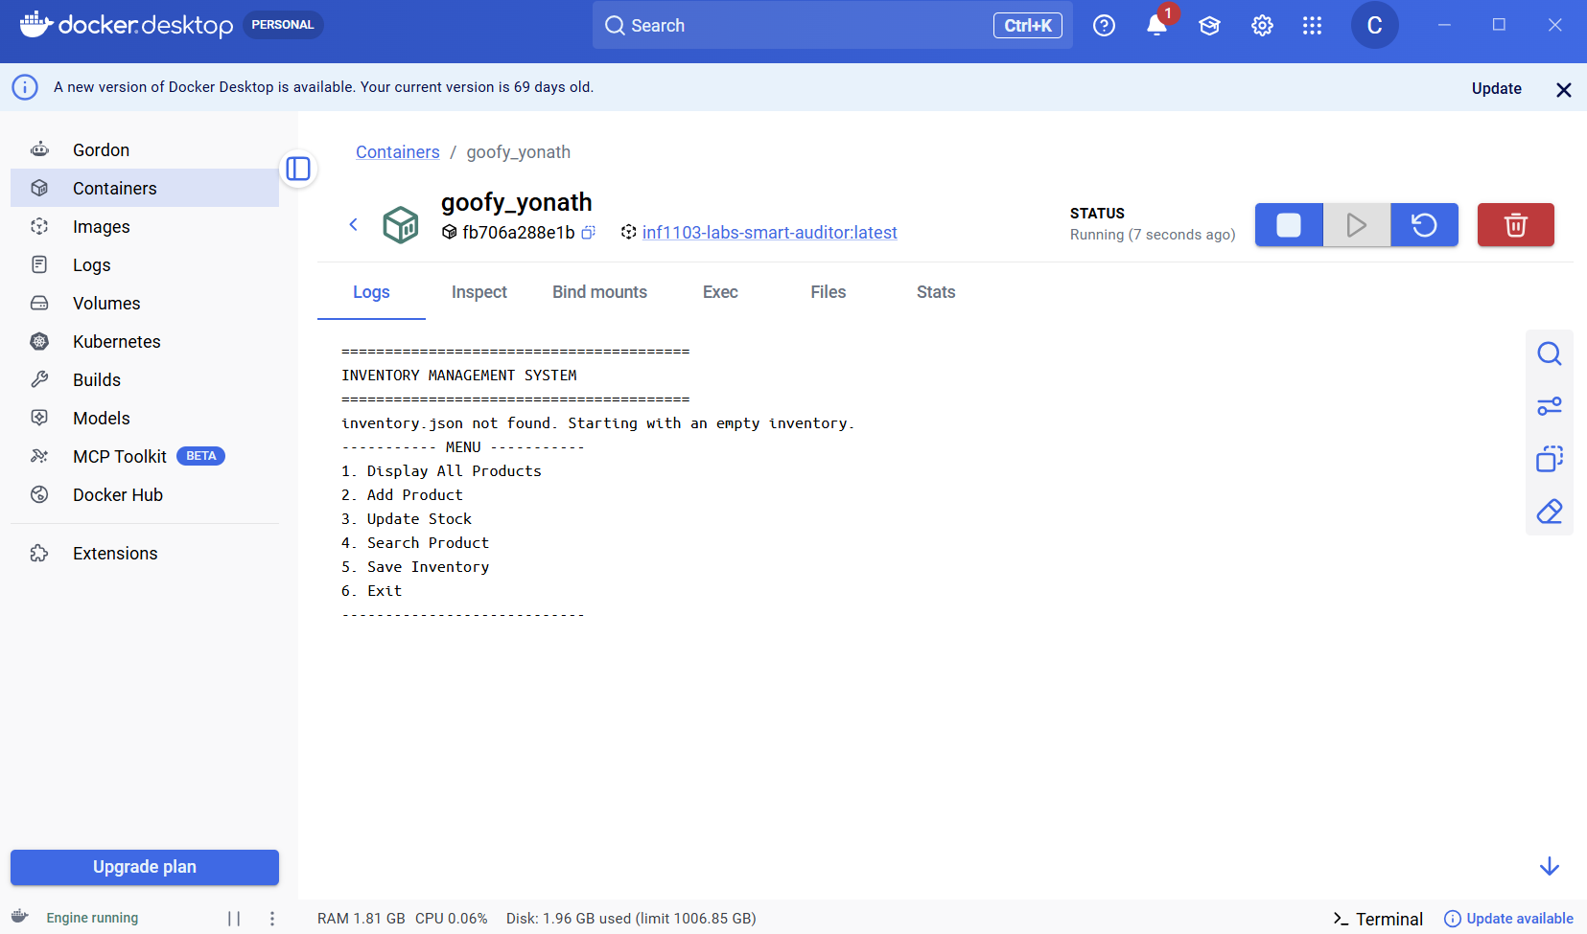

Evidence of type hints implementation:

